**Module 2: Process Multithreading Assignment**

Name

Institution

Instructor

Date

**Module 2: Process Multithreading Assignment**

**Overview**

In this assignment, you will use the Linux operating system and use Bash to learn the theory of multithreading.

**Instructions**

Research bash programming using this module’s readings and presentation.

**Part 1**

Program a bash script that outputs the following:

**Bash script .sh**

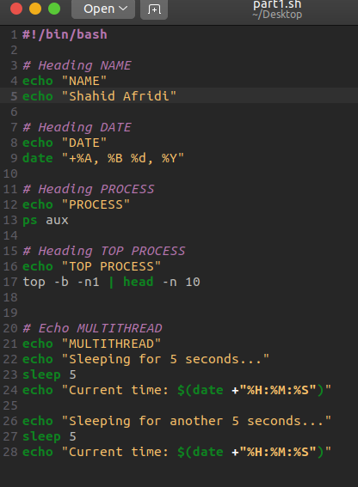

**Output**

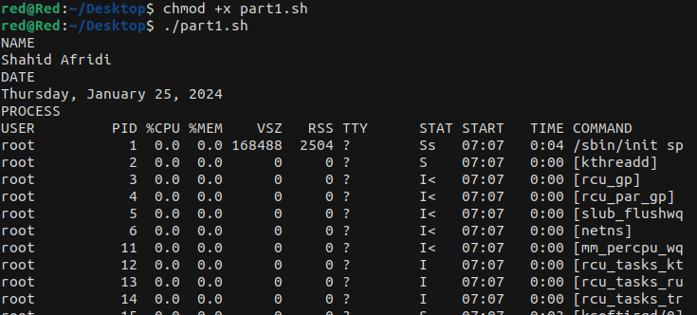

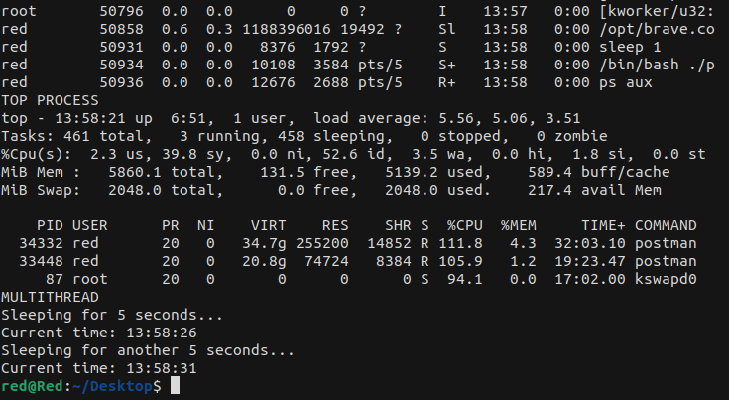

**Part 2**

**Program a bash script to demonstrate the theory of multithreading using processes:**

**Ipadresses.txt**

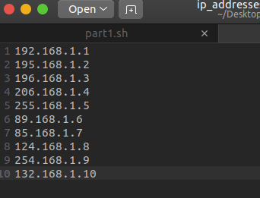

1. **Infinite loop:**

**Bash Script.sh**

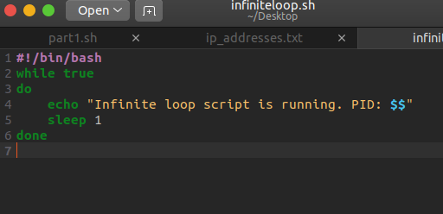

**Output:  
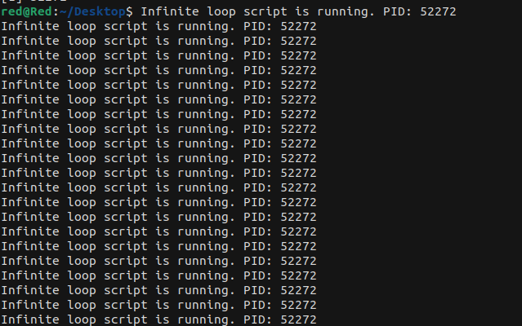**

1. **Ip address**

**BashScript.sh**

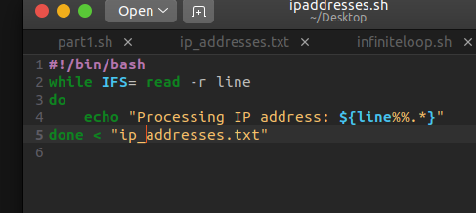

**Output**

